- Multi-standard: 21 HD formats supported in addition to PAL, NTSC and SD-SDI systems
- Up to 8 individually timed sync outputs
- Field & frame genlock to SD 625 & 525 line systems
- Wide timing range
- narrow timing resolution for all formats
- Highly Accurate HD system clock generation
- Low Jitter
- Good return loss for HD sync frequencies
- Fast reboot after power outage

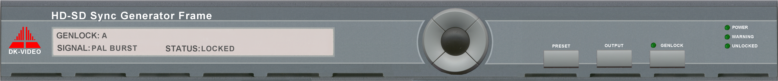

Next generation Sync Generator Platform

HD-SD Sync Generator Frame
Addresses HD, SD and hybrid format environments

In today’s environment, sync requirements are becoming increasingly diverse, as they need to support multiple production formats. A new flexibility is called for in Synchronising systems.

The design approach used allows a high degree of configuration flexibility – enough to match the potential evolution paths of a facility. An optimal combination of ‘factory fit’

options is provided together with feature upgrade paths - neither choice compromises the overall system reliability.

This provides the ideal compromise of a low-cost start point together with a wide choice of system upgrades. In this way the sync system can grow as the needs of the facility develop without committing the budget at the outset.

The next generation Sync generator shares the same potential feature set as the modules for the PT5210 series of sync generators. Additionally it supports HD tri-level sync outputs – enabled for up to 21 defined HD formats – including several different formats simultaneously.

The new user interface retains compatibility with preceding software versions to minimise learning curve

Key Features

Conforms to ITU-R and SMPTE recommendations

1U rack mounting format

Related changeover unit for redundant systems

Front panel or remote control

User named presets

Locks to analogue signals and precision references

Analogue and Digital Test generator options



- Configuration options
Data subject to alteration without notice.
Printed in Denmark
2004-04-19

- Analogue and SDI Test Signal generators
- Multiple independent SD Black Burst outputs
- Dual AES/EBU Digital Audio generator
- SDI digital genlock
- Longitudinal Timecode
- SDI Black/colour bars
- Multiple independent HD Tri-Level Sync Generator
- HD-SD Format Sync Generator

- Related Products

PT5202 Compact VariTime™ Sync generator
PT5210 VariTime™ Sync generator
PT5211 VariTime™ Changeover Unit
PT5230 Digital Video generator

contact us:

International: DK-AUDIO A/S • Marielundvej 37D • DK-2730 Herlev • Denmark
Tel: +45 44 85 02 55 • Fax: +45 44 85 02 50 • e-mail: info@dk-audio.com
UK: DK-AUDIO (UK) Ltd • Universal Marina • Crableck Lane • Sarisbury Green • Southampton • SO31 7ZN
Tel: +44 870 2414 118 • Fax: +44 870 2414 119 • e-mail: apa@dk-audio.com
Germany: DK-AUDIO Germany • Ziegeleiweg 16 • D-31832 Springe
Tel: +49 (0)5041 80 29 80 • Fax: +49 (0)5041 80 29 99 • e-mail: info.de@dk-audio.com
USA: DK-AUDIO America Inc. • 4417 East Villa Rita Drive • Phoenix • AZ 85032
Tel: +1 602 765 0532 • Fax: +1 602 765 1473• e-mail: jdt@dk-audio.com

www.dk-audio.com

